Module 5: Searching and Sorting Algorithms

Lesson 1: Searching Algorithms
1. What Is Searching?
Searching is the process of finding a specific element (called a key) within a list or collection of data.
It is one of the most common operations performed in computer programs.
Searching can be linear (checking one by one) or non-linear (using a divide-and-conquer approach).

2. Types of Searching Algorithms
Type | Description | Requires Sorted Data? | Time Complexity
Linear Search | Scans each element until it finds the target. | No | O(n)
Binary Search | Repeatedly divides the search interval in half. | Yes | O(log n)

Linear Search
Definition:
Linear Search is the simplest searching algorithm.
It checks each element in the list one by one until the target element is found or the end of the list is reached.

Step-by-Step Process:
- Start from the first element of the array.
- Compare the target value with the current element.
- If it matches, return the index.
- If not, move to the next element.
- Repeat until found or the list ends.

Code Example:
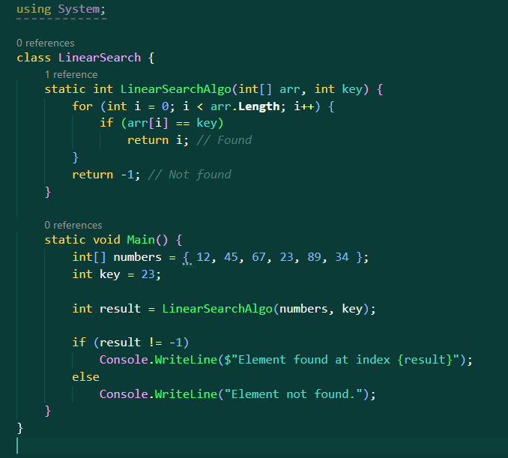
Output:
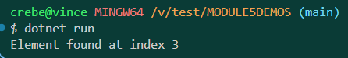
Example:

Imagine you are searching for your name on a class attendance sheet.
You go through each name one by one until you find yours — that’s Linear Search.

Binary Search
Definition:
Binary Search is a much faster method but works only on sorted data.
It repeatedly divides the search space into two halves.

Step-by-Step Process:
- Sort the array first.
- Set low to the first index and high to the last index.
- Find the mid index.
- If the element at mid equals the key, stop — found!
- If the key is smaller, search the left half.
- If the key is larger, search the right half.
- Repeat until found or no elements remain.

Code Example:
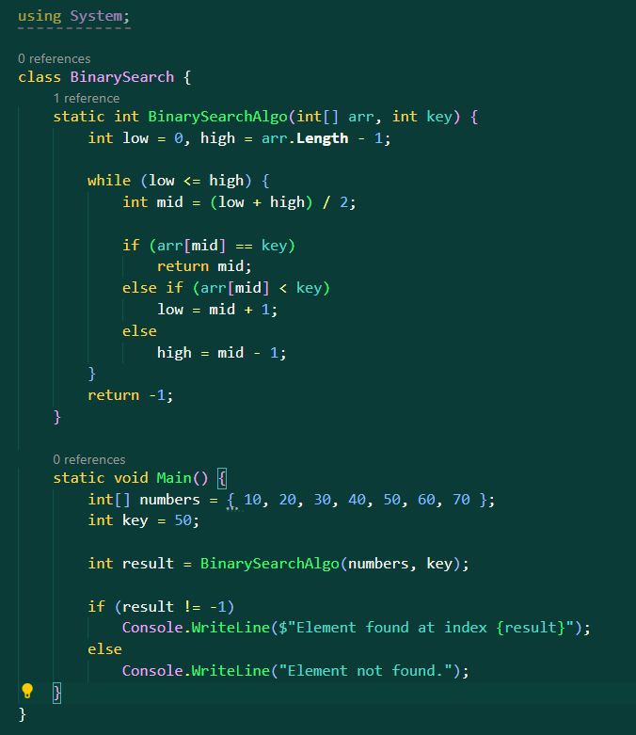
Output:
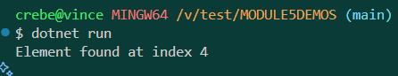

Example:
Imagine you are looking up a word in a dictionary.
Instead of starting at page 1, you open it halfway, check if the word is before or after, and keep narrowing down.

Comparison: Linear vs Binary Search
Feature | Linear Search | Binary Search
Works on sorted data | No | Yes
Speed | Slow for large data | Very fast
Complexity | O(n) | O(log n)
Example | Searching name in attendance list | Searching word in dictionary
Lesson 2: Sorting Algorithms

1. What Is Sorting?
Sorting means arranging data in a specific order — usually ascending or descending.
Sorting helps searching become faster and makes data easier to process.

2. Common Sorting Algorithms
Algorithm | Description | Time Complexity | Stable?
Bubble Sort | Repeatedly swaps adjacent elements if they are in the wrong order. | O(n²) | ✅
Selection Sort | Selects the smallest element and swaps it to the front. | O(n²) | ❌
Insertion Sort | Builds a sorted list one element at a time. | O(n²) | ✅
Quick Sort | Divides array into subarrays using a pivot. | O(n log n) | ❌
Merge Sort | Divides and merges sorted halves. | O(n log n) | ✅
Heap Sort | Converts array into heap and extracts largest repeatedly. | O(n log n) | ❌
Sorting Algorithms Explained (C# Program)

1. Bubble Sort
Concept:
Bubble Sort is one of the simplest sorting algorithms. It repeatedly goes through the list, compares adjacent elements, and swaps them if they are in the wrong order. Each complete pass pushes the largest unsorted value to the end of the list — just like bubbles rising to the top, hence the name.
How it works in the program:
The algorithm uses two loops. The outer loop represents how many passes will be made over the array, while the inner loop compares each pair of neighboring values.
If the element on the left is greater than the one on the right, the program swaps their positions.
After the first pass, the largest element is already at the end. The process repeats, shortening the comparison range each time until all elements are in order.
Example process:
If the array is [5, 1, 4, 2],
- First pass: [1, 4, 2, 5]
- Second pass: [1, 2, 4, 5]
- Third pass: [1, 2, 4, 5] (no swaps — sorted)
Efficiency:
Bubble Sort is intuitive but inefficient for large data sets.
It has a time complexity of O(n²) because it compares every element with every other element in the worst case.

2. Selection Sort
Concept:
Selection Sort divides the array into two parts: a sorted section and an unsorted section.
Initially, the sorted section is empty. The algorithm repeatedly selects the smallest element from the unsorted section and places it at the end of the sorted section.
How it works in the program:
The program uses a loop that marks the current index as the smallest. Then, another loop checks the remaining elements to find the actual smallest value.
Once found, the smallest value is swapped with the value at the current position. This process continues until the whole array is sorted.
Example process:
If the array is [64, 25, 12, 22, 11],
- Smallest is 11 → swap with 64 → [11, 25, 12, 22, 64]
- Next smallest is 12 → swap with 25 → [11, 12, 25, 22, 64]
- Next smallest is 22 → swap with 25 → [11, 12, 22, 25, 64]
Efficiency:
Selection Sort always performs the same number of comparisons regardless of the array’s order, so its time complexity is O(n²).
However, it does fewer swaps than Bubble Sort, making it slightly more efficient in practice.

3. Insertion Sort
Concept:
Insertion Sort builds a sorted list one element at a time.
It takes each new element and inserts it into its proper place among the previously sorted elements.
How it works in the program:
The algorithm starts from the second element of the array (since a single element is already “sorted” by default).
It stores this element temporarily and compares it with the elements before it.
While the previous elements are larger, it shifts them one position to the right to make space.
When it finds the correct position, it inserts the stored element there.
This repeats until all elements have been processed.
Example process:
For [5, 2, 4, 6, 1, 3],
- Insert 2 before 5 → [2, 5, 4, 6, 1, 3]
- Insert 4 before 5 → [2, 4, 5, 6, 1, 3]
- Insert 1 at the start → [1, 2, 4, 5, 6, 3]
- Insert 3 between 2 and 4 → [1, 2, 3, 4, 5, 6]
Efficiency:
Insertion Sort is very efficient for small datasets or arrays that are almost sorted.
Its average and worst-case time complexity is O(n²), but in the best case (already sorted), it runs in O(n).

4. Quick Sort
Concept:
Quick Sort is a divide-and-conquer algorithm. It divides the array into smaller subarrays around a “pivot” value, sorting those smaller parts recursively.
How it works in the program:
The algorithm selects a pivot element (in this program, the last element in the array).
It then rearranges the array so that all elements smaller than the pivot are placed to its left, and all elements larger than the pivot are placed to its right.
After this rearrangement, the pivot is in its correct position.
The program then recursively applies the same process to the left and right halves of the array until all parts are sorted.
Example process:
If the array is [10, 7, 8, 9, 1, 5] and the pivot is 5,
- After partitioning: [1, 5, 8, 9, 10, 7] (pivot 5 in correct position)
- Recursively sort left [1] and right [8, 9, 10, 7] until the entire array is sorted.
Efficiency:
Quick Sort is one of the fastest sorting algorithms in practice, with an average time complexity of O(n log n).
However, if the pivot is always the smallest or largest element (a bad pivot choice), the time complexity can degrade to O(n²).
5. Merge Sort
Concept:
Merge Sort is also based on divide and conquer.
It divides the array into two halves, sorts each half separately, and then merges them back together in sorted order.
How it works in the program:
The algorithm starts by repeatedly splitting the array into two halves until each half contains only one element (which is, by definition, sorted).
Then, it merges these single-element arrays back together — always comparing elements from both halves and picking the smaller one to rebuild the sorted sequence.
This merging process continues upward until all small arrays have been combined into one fully sorted array.
Example process:
For [4, 2, 1, 3],
- Split into [4, 2] and [1, 3]
- Sort each half → [2, 4] and [1, 3]
- Merge both → [1, 2, 3, 4]
Efficiency:
Merge Sort consistently runs in O(n log n) time, regardless of the data’s initial order.
However, it uses extra space because temporary arrays are created during merging.
It’s also stable, meaning it preserves the relative order of equal elements.

6. Heap Sort
Concept:
Heap Sort works using a special data structure called a binary heap, specifically a max heap, where each parent element is greater than its children.
How it works in the program:
The algorithm first transforms the entire array into a max heap.
In this structure, the largest element is always at the root (the beginning of the array).
The algorithm then swaps this largest element with the last element in the array, effectively placing it in its final sorted position.
After that, it reduces the heap size by one (ignoring the sorted part) and rebuilds the heap to find the next largest value.
This process repeats until the entire array is sorted in ascending order.
Example process:
If the array is [4, 10, 3, 5, 1],
- Build max heap → [10, 5, 3, 4, 1]
- Swap root (10) with last → [1, 5, 3, 4, 10]
- Rebuild heap → [5, 4, 3, 1, 10]
- Repeat until sorted → [1, 3, 4, 5, 10]
Efficiency:
Heap Sort has a time complexity of O(n log n) in all cases and requires only constant extra space (O(1)).
It’s not a stable sort, but it’s highly reliable and often used when consistent performance is required.

🧾 Summary Table
Sorting Algorithm | Best Case | Average Case | Worst Case | Space | Stable | Key Characteristic
Bubble Sort | O(n) | O(n²) | O(n²) | O(1) | ✅ | Repeatedly swaps adjacent elements
Selection Sort | O(n²) | O(n²) | O(n²) | O(1) | ❌ | Finds the smallest element and places it at the front
Insertion Sort | O(n) | O(n²) | O(n²) | O(1) | ✅ | Builds the sorted list one element at a time
Quick Sort | O(n log n) | O(n log n) | O(n²) | O(log n) | ❌ | Divides the list around a pivot and sorts recursively
Merge Sort | O(n log n) | O(n log n) | O(n log n) | O(n) | ✅ | Splits and merges arrays in order
Heap Sort | O(n log n) | O(n log n) | O(n log n) | O(1) | ❌ | Uses a binary heap to extract max values

